**Simulation and circuit analysis of HEMP filter evaluation as per MIL-STD-188-125-1**

A project thesis submitted in partial fulfillment of the requirement for the award of degree

**Bachelor of Technology**

in

**Department of Electronics and Communication Engineering**

By

**Kammila Vignan Sai**

**ID No. 170040349**

|  |  |  |
| --- | --- | --- |
| **Mr. P Siva Kumar**  Scientist-C  SAMEER CE-3  **Company Guide** | **Mr. V Shourie Reddy**  Regional Manager  KLEF, Vizag  **Practice School Guide** | **Dr. M Ravi Kumar**  Assistant professor  KL University  **University Guide** |

Under the Guidance of



**Department of Electronics and Communications**

**K L University, Green Fields,**

**Vaddeswaram – 522502, Guntur(Dist), Andhra Pradesh, India.**

**September 2020**

**Interim Report**

**Simulation and circuit analysis of HEMP filter**

**evaluation as per MIL-STD-188-125-1**



**Bonafide Certificate**

This is to certify that this On-job Engineering Interim report entitled “**Simulation and circuit analysis of HEMP filter evaluation as per MIL-STD-188-125-1**” submitted to Department of Electronics and Communication Engineering, KL Deemed to be University, Guntur, in connection with the University internship program is a Bonafede record of work done by “**Kammila Vignan Sai** ” under my supervision at the “SAMEER CE-3, Vizag.

**Mr. P Siva Kumar**

Scientist-C

SAMEER CE-3

**Table of Contents**

|  |  |  |
| --- | --- | --- |
| **S.No.** | **Chapter** | **Page Nos.** |
| A. | **Company Overview** | 5 |
| B. | **Existing technologies** | 6 |
| C. | **Possible contributions to the limitations in current technology.** | 7 |
| D. | **Targets/Tasks**  **Strategy**  **Achievements** | 8 |
| 1. | **Objective** | 9 |
| 2. | **Conceptual Framework**  2.1 EMP (Electro Magnetic Pulse)  2.1.1. EMP definition  2.1.2. EMP waveforms  2.1.3. EMP characteristics  2.1.4. EMP Components  2.1.5. Double Exponential pulse Expression  2.2 Marx Generator  2.2.1. Marx generator introduction  2.2.2. Marx generator characteristics  2.3 Transient Surge Protection  2.3.1. Transients  2.3.2. HEMP/EMP filters  2.3.2.1.HEMP/EMP filter function  2.3.2.2.MOV’s (Metal Oxide Varistors) | 10-16 |
| 3. | **Theoretical Analysis**  3.1 PCI (Pulsed Current Injection)  3.1.1. PCI Introduction  3.1.2. PCI Test Procedures based on MIL STD 188-125-1  3.1.2.1. Definitions  3.1.2.2. General Requirements  3.1.2.3. PCI test equipment requirements  3.1.2.4. Analysis of verification test data  3.1.2.5. Detailed requirements  3.2 LTSPICE  3.2.1. Overview  3.2.2. Device Models  3.2.3. LTSPICE directive text  3.2.4. SPICE transient analysis | 17-24 |
| 5. | **Experimental Investigations-Mid course correction**  4.1 Surge Generation  4.1.1. Marx Generator design procedure.  4.1.2. Spark-gap design procedure  4.1.2.1. Spark gap sub circuit.  4.1.2.2. Spark gap symbol design.  4.1.3. Final Surge generator circuit using modelled spark gap.  4.2 Surge Suppression | 25-35 |
| 6. | **Limitations** | 36 |
| 7. | **Conclusion** | 37 |
| 8. | **References** | 38 |

1. **Company Overview**



Society for Applied Microwave Electronics Engineering & Research (SAMEER) is a Research & Development Institute under the administrative control of the Ministry of Electronics and Information Technology, Government of India. Its main objective is to promote the growth of Science and Technology in the field of RF/Microwave Electronics, Electromagnetics, Optoelectronics, millimeter-wave Technology, and its allied areas. SAMEER has its headquarters at Mumbai and centers at Chennai, Kolkata, Navi Mumbai, and Visakhapatnam.

Centre for Electromagnetic Environmental Effects (E3) under SAMEER, located in Visakhapatnam, has been started in 2014 with specialized E3 test facilities as per MIL-STD 461E/F,464 and MIL-STD 188-125-1&2.

SAMEER Centre for E3 has been pursuing its objective of doing Electromagnetic Environmental Effects (E3) Research, Development, Test, and Evaluation. The E3 facility specializes in a variety of capabilities, ranging from box level to complete system-level testing. The center is set to achieve excellence in application-oriented research in the areas of Electromagnetic Environmental Effects (E3).

**Area of work:**

* Electromagnetic Environmental Effects (E3) Research & Development.
* Electromagnetic Environmental Effects (E3) Prediction & Analysis.
* Electromagnetic Environmental Effects (E3) Design Consultancy services.
* Electromagnetic Environmental Effects (E3) Compliance Testing.

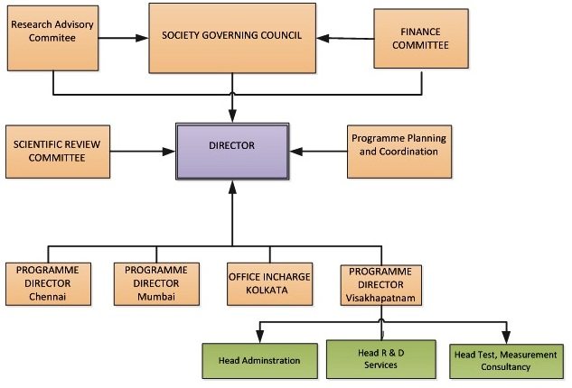**Organization chart:**

1. **Existing Technologies and comprehensive understanding.**

Center for Electromagnetic Environmental Effects (E3) is widely know for its wide array of test equipment for HEMP, PCI, EMI/EMC, 3D modelling testing and consultancy technologies. It also includes the India’s largest EMP test facility with a 100V/m test capacity.

The EMP labs in E3 consists of three main E1 surge generators, in which one is for radiated pulse and two are for conductive pulse. The radiative pulse generator can generate a pulse with a peak of 1000KV and has a pulse characteristics 2/28ns. It consists of 121/2 stages with each stage generating 800V. The two conductive generators have capacities of 80KV and 300KV respectively and one is a gas-based dielectric and the other with an oil-based dielectric.

The PCI facility uses the two conductive surge generators to test the HEMP filters and their working conditions in a conducted EMP environment. The testing involves close monitoring of the pulse output and the residual current output from the filters. The whole setup is enclosed in an EMP shielded facility in order to protect the equipment from the High current pulse produced. The EMP test facility uses the radiative surge generator to the HEMP shields and their working conditions in a radiated EMP environment. The generated is connected to the transmission lines which consists of 10 lines in total which in combined produces a 100V/m field. The shield/enclosure which is to be tested is kept under the designated testing area, and its EMP shielding effects are monitored while the pulse is passed.

The PCI facility tests and evaluates based on the latest HEMP protection specifications, MIL-STD 188-125-1, and DEF STAN 59-188 Parts 1 and 2, which define protection requirements for fixed and mobile critical facilities and infrastructure against the effects of a HEMP event. The EMI/EMC test facilities are based on specialized E3 test specifications as per MIL STD 461E/F,464.

The filters designing mainly consists of the use of the MOVs and GDTs which are chosen with respective to their VI curve characteristics. The simulation of these physical components is difficult as there are many environmental factors to be considered while simulating them. The simulation software may not take these factors into account. However, the simulation of shielding can be done using simulation software like CST, FEKO and HFSS. The radiated EMP can be simulated on to a designed 3D shielded enclosure and analyze the attained results. There is also an existing 3D modelling lab for the simulation and modelling of these shields using high computational power systems.

The applications of these testing are widely used in the space and defense industry as the components used in the space & military equipment should sustain an EMP attack. And also, the applications include lightning and ESD pulses filtering and shielding.

1. **Possible contributions to the limitations in current technology.**

Even though there are physical equipment used for testing purposes, there is some lacking in the area of filter simulation. This gap is due to the unavailability of some components in the circuit simulation software. This has to do with the wide range of environmental effects affecting the working of the component in the real-world scenario. One such component is the spark gap.

The spark gap is used in all the E1 surge generators where it plays a vital role in generation of the spark. Each generator has its own set of dielectrics which changes how the spark gap works. The spark gap’s main working characteristic is its breakdown voltage, which depends on the type of dielectric between it. The 300KV generator consists of a gas-based dielectric(a combination of SF6 and N2O). The breakdown voltage depends on the ratio of pressures of SF6 and N2O in the Marx generator. Though, the 80KV generator consists of an Oil-based dielectric whose volume of oil inside it is kept constant.

Due to these physical characteristics affecting the breakdown voltage, it is nearly impossible to make a relevant spark gap component in a simulation software. Due to this reason, all the surge generation and surge suppression simulations done in the company are with possible alternatives like switches. Their characteristics are designed in relevant to a spark gap characteristic. Using this alternative gives the desired results but not the desired understanding of the working of the circuits.

Therefore, there is a possible chance of designing and using a spark gap model in the simulations of surge generation and suppression. This would be a useful contribution to the working company and also a n informative study analysis.

Furthermore, the simulations of HEMP filters include either testing filters for power electronics or for communication lines. But they do not include both applications into one single circuit and simulation. This is due to the lack of available MOV libraries in the simulation software. This is where my contribution of HEMP filter circuit satisfying both power electronics and communication lines come in. It also satisfies the test specifications of MIL-STD-188-125-1.

The contributions will be an analytical based study results using the limits of the existing technologies. As simulations are said to be safest way of prototyping and testing before the actual implementation of the circuits, the contributions can play a vital role in the area of simulation used it the company labs.

1. **Target/Tasks**

Following are the targets set by the company and their status, respectively.

|  |  |
| --- | --- |
| **Tasks/Targets** | **Status** |
| A study on ce3.SAMEER’s area of work | Completed |
| A study on EMP and its components | Completed |
| A study on the Marx generator and PCI | Completed |
| A study on Transient surge generation and suppression | Completed |
| A study of standards of MIL-STD-188-125-1&2 | Completed |
| Learning circuit simulation software: LTSPICE and PSPICE | Completed |
| A study on modelling of a spark gap component in a circuit simulation software | Completed |
| Modelling of a spark gap | Completed |
| Circuit simulation of Marx generator | Completed |
| Circuit simulation of Marx generator using modelled spark gap | Completed |
| A brief analysis of in-house PCI equipment and their working | Completed |
| Circuit simulation of Surge suppression circuit. | Currently working. To be completed by 08-09-2020 |
| Circuit analysis of HEMP filter circuit | Currently working. To be completed by 18-09-2020 |

**Strategy**

The tasks and targets are being done meticulously under the guidance and instructions of Mr. P Siva Kumar Sir, Scientist-C, SAMEER. Work is done with the available resources in the company and the help from the Senior Engineers or the Junior scientists.

Albeit the assigned work is challenging, the work is completed much before the set deadlines. Usage of the existing facilities and wide range of research references helps in the completion of the tasks/targets set.

**Achievements**

The following are the major achievements in the company till date.

* Modelling of a Spark Gap component in LTSPICE.
* Circuit simulation of Marx Generator using modelled spark gap.
* Circuit simulation of Marx Generator and HEMP filter circuit using modelled spark gap.

1. **Objective**

For uses in war zones, national defense and homeland security, High-altitude Electro Magnetic Pulse (HEMP) filters help to safeguard equipment and systems against the potentially devastating effects of nuclear blasts high in the atmosphere. The pulse caused by such an event could knock out military computer and communications networks as well as civil and commercial infrastructure.

For example, the intense electromagnetic pulse created by a high-altitude nuclear blast could disable, damage, or destroy electrical power supply networks, unprotected items of electrical equipment and electrical controls for key service industries over a wide area of the Earth’s surface. Any equipment containing microchips would be particularly vulnerable and could be damaged or destroyed in a fraction of a second.

The latest HEMP protection specifications, MIL-STD 188-125-1, and DEF STAN 59-188 Parts 1 and 2, define protection requirements for fixed and mobile critical facilities and infrastructure against the effects of a HEMP event. The specifications set out three different frequency components of the pulse – an early-time E1 pulse, intermediate-time E2 pulse and late-time E3 pulse. In terms of radiated fields, the E1 component of the HEMP pulse reaches field levels of 50 kV/m within 10 ns, E2 HEMP attains 100 V/m between 1 microsecond and 1 second, and E3 HEMP hits 40 V/km for times between 1 and several hundred seconds.

Simulation and circuit analysis of HEMP filter evaluation as per these standards include generating a MIL-STD HEMP short pulse and filtering the currents using a HEMP filter. This can be done in two steps.

1. Generation of HEMP short-pulse using a Marx generator circuit with its characteristics satisfying MIL-STD-188-125 -1 using a Marx generator circuit.
2. Suppression of the generated HEMP short pulse using a filter circuit with its characteristics satisfying MIL-STD-188-125 -1
3. **Conceptual Framework**
   1. **EMP (Electromagnetic pulse)**
      1. **EMP definition**

An electromagnetic pulse or  EMP, also called a transient form of electromagnetic disturbance, is a burst of electromagnetic radiation. It occurs as radiated, even electric or a magnetic field and also a conducted electrical current which depends upon the source.

* + 1. **EMP waveforms**

The waveform describes as to how the instantaneous amplitude changes with time. The Real pulses usually tend to be complicated, and so the simplified kind of models are used.

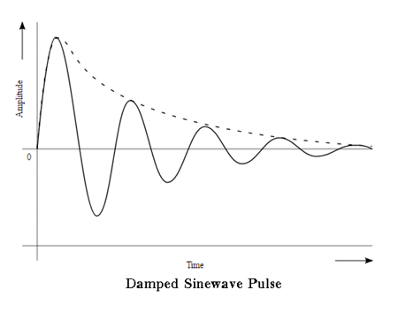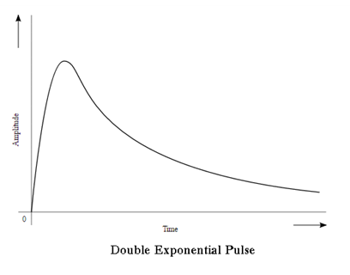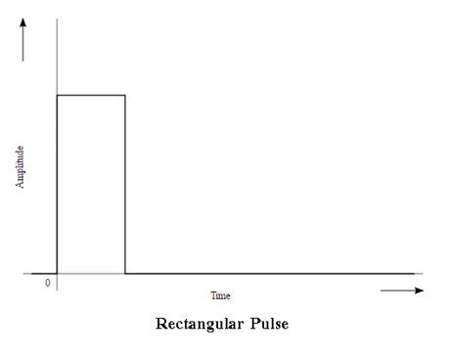

**Figure 2.1.1: Different EMP waveforms.(a) Rectangular pulse (b) Double Exponential pulse (c) Damped Sinewave Pulse**

* + 1. **EMP characteristics**

An electromagnetic pulse is like electromagnetic radiation. The meaning of short duration is it can spread about a range of different frequencies. Here are the general characteristics of the electromagnetic pulse:

• Type of the energy whether radiated or electric or magnetic

• The range or the spectrum of different frequencies that are present.

• In the Pulse waveform, kind of shape, its duration, and the amplitude.

* + 1. **EMP Components**

The case of a nuclear electromagnetic pulse differs from other kinds of electromagnetic pulse (EMP) in being a complex electromagnetic multi-pulse. The complex multi-pulse is usually described in terms of three components, and these three components have been defined as such by the international standards commission called the International Electrotechnical Commission (IEC).

The three components of nuclear EMP, as defined by the IEC, are called E1, E2 and E3.

**E1 pulse:** The E1 pulse is the very fast component of nuclear EMP. The E1 component is a very brief but intense electromagnetic field that can quickly induce very high voltages in electrical conductors. The E1 component causes most of its damage by causing electrical breakdown voltages to be exceeded. E1 is the component that can destroy computers and communications equipment; and it changes too fast for ordinary lightning protectors to provide effective protection against it. Consumer transient protectors are becoming increasingly able to handle faster rise-time pulses, though. There are special transient protectors that are fast enough to suppress nuclear EMP.

The E1 component is produced when gamma radiation from the nuclear detonation knocks electrons out of the atoms in the upper atmosphere. The electrons begin to travel in a generally downward direction at relativistic speeds (more than 90 percent of the speed of light). In the absence of a magnetic field, this would produce a large pulse of electric current vertically in the upper atmosphere over the entire affected area. The Earth's magnetic field acts on these electrons to change the direction of electron flow to a right angle to the geomagnetic field. This interaction of the Earth's magnetic field and the downward electron flow produces a very large, but very brief, electromagnetic pulse over the affected area

**E2 pulse:** The E2 component is generated by scattered gamma rays and inelastic gammas produced by weapon neutrons. This E2 component is an "intermediate time" pulse that, by the IEC definition, lasts from about one microsecond to one second after the beginning of the electromagnetic pulse. The E2 component of the pulse has many similarities to the electromagnetic pulses produced by lightning, although the electromagnetic pulse induced by a very close lightning strike may be considerably larger than the E2 component of a nuclear EMP. Because of the similarities to lightning-caused pulses and the widespread use of lightning protection technology, the E2 pulse is generally considered to be the easiest to protect against.

According to the United States EMP Commission, the main potential problem with the E2 component is the fact that it immediately follows the E1 component, which may have damaged the devices that would normally protect against E2.

**E3 pulse:** The E3 component is very different from the other two major components of nuclear EMP.   The E3 component of the pulse is a very slow pulse, lasting tens to hundreds of seconds, that is caused by the nuclear detonation heaving the Earth's magnetic field out of the way, followed by the restoration of the magnetic field to its natural place.   The E3 component has similarities to a geomagnetic storm caused by a very severe solar coronal mass ejection (CME).4, 5, 6    Like a geomagnetic storm, E3 can produce geomagnetically induced currents in long electrical conductors, which can then damage or destroy components such as power line transformers.5  These currents are often called quasi-DC currents because they resemble the direct current from a battery more than what most people think of as a pulse.  Nearly all of the damage from E3 in modern systems occurs to the AC power grid, which is generally not designed to handle direct currents, especially in critical devices such as power transformers.

Because of the similarity between solar-induced geomagnetic storms and nuclear E3, it has become common to refer to solar-induced geomagnetic storms as "solar EMP."   At ground level, however, "solar EMP" is NOT known to produce an E1 or E2 component.  The phrase "solar EMP" has caused a huge amount of confusion in the general public.

* + 1. **Double Exponential pulse Expression**

The double-exponential shape is given in figure 2.1.2 as follows:

**E(t) = E0 k ( e −αt − e−β t )h(t)**

where E0 is the amplitude, α and β are the characteristic mathematical parameters, and h(t) is the unit-step function. The amplitude factor k is necessary to create different double-exponential pulse shapes with variable parameters, but a constant amplitude.

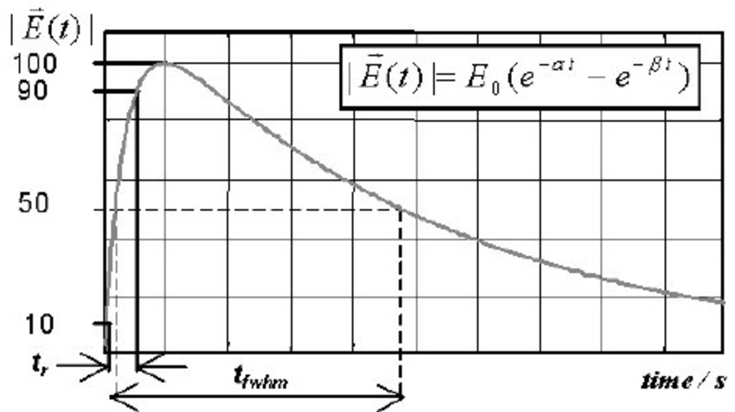

**Figure 2.1.2: Double-exponential pulse**

In total five different pulse generating devices are available. Table 2.1.1 shows the rise time (tr) and the full width half max value (fwhm) of the different pulses.

|  |  |  |
| --- | --- | --- |
| **Pulse** | **Rise time tr** | **fwhm** |
| UWB | 100ps | 2.5ns |
| EMP(fast) | 1.5ns | 80ns |
| EMP(med.) | 5ns | 300ns |
| UMP-slow EMP | 500ps-10ns | 2.5ns-1600ns |
| EMP (slow) | >10ns ≤20ns | 500ns |

**Table 2.1.1: Rise time (tr) and the full width half max value (fwhm) of the different pulses.**

* 1. **Marx Generator**
     1. **Marx generator introduction**

A Marx generator is an electrical circuit first described by Erwin Otto Marx in 1924.[Its purpose is to generate a high-voltage pulse from a low-voltage DC supply. Marx generators are used in high-energy physics experiments, as well as to simulate the effects of lightning on power-line gear and aviation equipment.

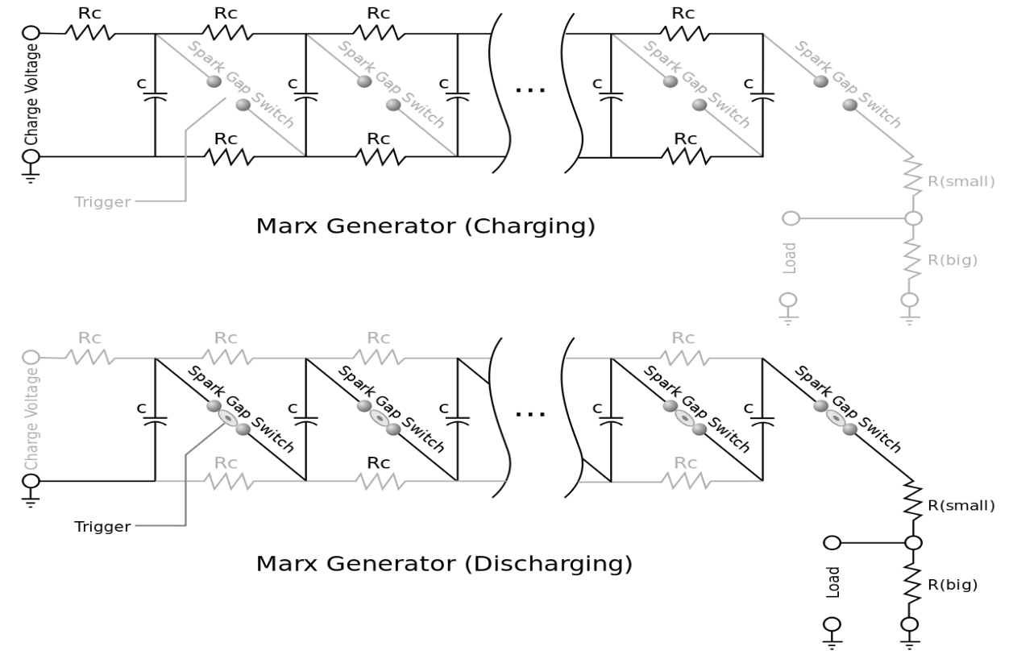

**Figure 2.2.1: Marx generator circuit. (a) Charging (b) Discharging**

* + 1. **Marx generator characteristics**

**Erection:** The process of the spark gaps connecting the capacitors in series to create the high voltage is called erection

**Erection voltage:** The voltage at the erection is called the erection voltage

**Trigger Circuit:** The choice of Marx switches is dependent on the operating voltage, pulse repetition frequency, and lifetime, and switching support requirements. Solid state switches may be used in low voltage applications. However, many Marx generators operate in regimes where the only viable alternative is a spark gap. Spark gap technology is broadly split into liquid filled and gas filled systems. For both cases, the medium provides both the cooling and switching characteristics. Maximum repetition rates are achieved by flowing the medium through the switching region to carry away heat and recover voltage hold-off capability quickly. Liquid systems typically use oil or water but can be based on a variety of other liquids. Liquid systems have excellent thermal mitigation properties. However, these systems tend to use pumps and filters to remove contamination, adding to volume and complexity. Gas systems can be based on a variety of gases, depending on repetition rates, spark gap lifetime, and safety concerns the highest repetition rate systems use high pressure hydrogen due to its ability to recover its insulating properties quickly after firing.

**Spark gap:** A spark gap consists of an arrangement of two conducting electrodes separated by a gap usually filled with a gas such as air, designed to allow an electric spark to pass between the conductors. When the potential difference between the conductors exceeds the breakdown voltage of the gas within the gap, a spark forms, ionizing the gas and drastically reducing its electrical resistance. An electric current then flows until the path of ionized gas is broken, or the current reduces below a minimum value called the "holding current". This usually happens when the voltage drops, but in some cases occurs when the heated gas rises, stretching out and then breaking the filament of ionized gas. Usually, the action of ionizing the gas is violent and disruptive, often leading to sound (ranging from a snap for a spark plug to thunder for a lightning discharge), light and heat.

* 1. **Transient Surge Protection**
     1. **Transients**

Transients (momentary spikes in voltage or current) can disrupt or damage the products connected to signal or power lines. Common sources of transient’s energy coupled from lightning, electrostatic discharge and circuits experiencing a sudden change in current due to a switch opening or a short occurring. Transient protection devices attempt to re-direct the energy in these transients by taking advantage of the differences between the transient waveform and the intended signal or power waveform. The most common transient protection schemes limit the voltage amplitude, current amplitude, or transition times on the circuit they are protecting.

Some examples for transient Surge protectors:

* Voltage Limiters
* Diodes
* Varistors
* Thyristors
* GDTs (Gas Discharge Tubes)
* Current-Limiting Devices
* Transition-Time Limiting Devices
  + 1. **HEMP/EMP filters**

Unlike most commercially available EMI filters, EMP/HEMP Filters are specifically designed to counter the conducted emissions from High Power Electromagnetics (HPEM), unintentionally, or intentionally, induced into the power line of a protected system. Subsequently, EMP/HEMP filters must tackle very different energy levels, waveforms, and frequencies than EMC filters, and understanding of these differences is critical in understanding the protection they provide. This white paper aims to describe HPEM threats to modern electronics, the differences between EMC and EMP/HEMP protection, and details regarding recently available EMP/HEMP Filter technology.

A true EMP/HEMP Filter is designed to work within a HEMP shielding system to provide in-line suppression to the power line of HEMP waveforms with mission critical equipment (MCE) without disrupting the operation of the MCE. For equipment that would suffer from the hard shutoff behavior of a surge protector/arrester, but still requires HEMP waveform suppression, EMP/HEMP Filters provide protection while allowing desired DC and AC power signals to pass through. Due to the substantial power levels and frequency range of HEMP energy, an EMP/HEMP Filter also needs to be robust enough to absorb the potentially destructive overshoot voltage.

* + - 1. **HEMP/EMP filter function**

An EMP/HEMP Filter includes a suppression circuit that enters a high off-state impedance, virtually transparent to the downline circuits, during normal operation. In case of a voltage overshoot that exceeds the switching voltage, the filter suppression circuitry switches to a very low impedance, high attenuation mode that shorts the excessive voltage and absorbs the excess energy within the filter. As long as the high voltage exposure continues, an EMP/HEMP filter is designed to maintain suppression until the voltage drops to a safe level below the switching voltage. The high impedance suppression function of an EMP/HEMP filter is enabled by the use of a Metal Oxide Varistor (MOV), which is a type of voltage-dependent and non-linear resistor (VDR), or variable resistor. When a MOV is exposed to voltage that exceeds its breakdown voltage, the MOV impedance drops from its normal high impedance state to a low impedance state. In an EMP/HEMP Filter, the MOV is a short between the power line and a discharge resistor, which is how the excess voltage is absorbed. The main conducting region of a MOV acts like a dielectric below the clamping voltage, which allows the varistor to act like a capacitor rather than a resistor. In AC circuits, the capacitance affects the body resistance of the MOV in the non-conducting leakage region of its current/voltage (IV) characteristic. This means that when exposed to higher frequency AC, RF, and microwave frequencies, the MOV’s leakage resistance drops as a function of frequency, thus enabling very high attenuation at higher frequencies.

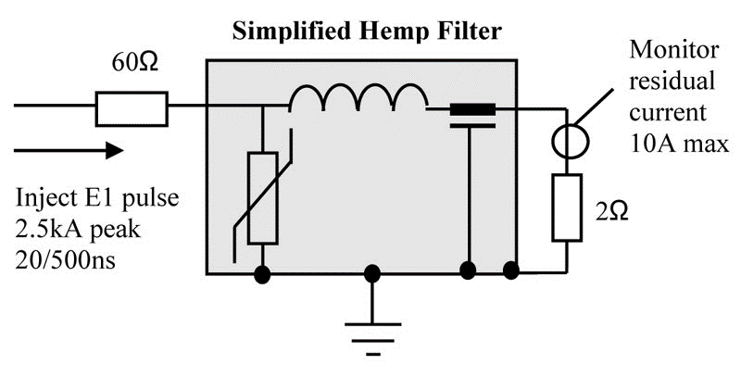

**Figure 2.3.1: Simplified HEMP Filter circuit**

* + - 1. **MOV’s (Metal Oxide Varistors)**

MOV is the most commonly used type of varistor. It is called so as the component is made from a mixture of zinc oxide and other metal oxides like cobalt, manganese and so on and is kept intact between two electrodes which are basically metal plates. MOV’s are the most used component to protect heavy devices from transient voltages. A diode junction is formed between each border of the grain and its immediate neighbor. Thus, an MOV is basically a huge number of diodes that are connected parallel to each other.  They are designed to be in the parallel mode as it will have better energy handling ability. But, if the component is meant for providing better voltage rating, it is better to connect them in series.

A reverse leakage current appears across the diode junctions of each border when an external tiny voltage is applied across the electrodes. The current produced will also be very small. But, when a large voltage is applied across the electrodes, the diode border junction breaks down as a result of the combination of electron tunneling and avalanche breakdown. Thus, the device is said to show a high level of non-linear voltage – current characteristics. From the characteristics, it should also be noted that the component will have low amount of resistance at high voltages and high resistance at low voltages.

The only problem with this component is that they cannot withstand the transient voltage more than the exceeded rating. They tend to deteriorate after a certain level. If so, they will have to be replaced at times. When they absorb the transient voltage, they tend to dissipate it as heat. When this process continues repetitively for some time, the device begins to wear out due to the excessive heat.

They can be connected in parallel for increased energy-handling capabilities. MOVs can also be connected in series to provide higher voltage ratings or to provide voltage rating between the standard increments.

**MOV Specifications**

* **Maximum working voltage** is the maximum steady-state, DC voltage. In this case, the value of the typical leakage current will be lesser than a specified value.
* **Maximum clamping voltage** is obtained when a certain pulse current is applied to the component to obtain a maximum peak voltage.
* **Surge shift** refers to the variation in voltage after a surge current is given.
* **Energy absorption**refers to the maximum energy that is dissipated for a certain waveform without many problems.
* **Leakage current**
* **Response time**
* **Maximum AC RMS voltage**refers to the maximum amount of RMS voltage that can be delivered to the component

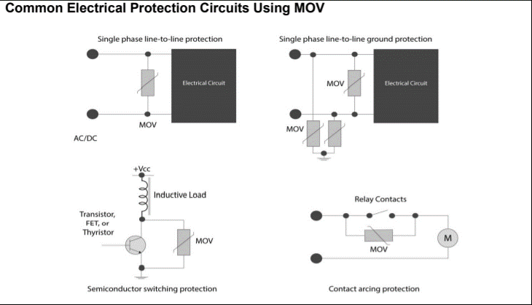

**Figure 2.3.2: Common Electrical Protection Circuits using MOV’s**

1. **Theoretical Analysis**

As the project is based on the MIL STD 188-125 1&2, we would be focusing on the analysis of the characteristics that are needed for this particular project.

* 1. **PCI (Pulsed Current Injection)**
     1. **PCI Introduction**

Pulsed current injection (PCI) is a convenient and effective technique to test the vulnerability of electric/electronic equipment to high-altitude electromagnetic pulses (HEMPs). The test consists in injecting an electromagnetic (EM) threat-relatable transient onto the cables of the equipment under test (EUT) by an injecting probe, and monitoring EUT robustness against such a stress waveform. Compared with radiated tests, where the system is completely immersed in the EM environment, PCI allows more accurate screening and detection of critical cables (and points of entry), by resorting both to common mode and single wire-to-ground noise injection. Moreover, since the test is run on the tabletop, PCI is definitely attractive in terms of required time and costs.

* + 1. **PCI Test Procedures based on MIL STD 188-125-1 Appendix B**

This Appendix establishes PCI test procedures for electrical point-of-entry (POE) protective devices required for low-risk high-altitudeelectromagnetic pulse (HEMP) protection of ground-based facilities with critical, time-urgentmissions. The procedures are applicable for testing other HEMP-hardened facilities, whenspecified by the procurement documentation.

**Applications:** These procedures shall be used for acceptance testing after construction of the HEMP protection subsystem and for verification testing of electrical POE protective treatments after the facility is completed and operational.

* + - 1. **Definitions**
* **Norms:** Scalar quantities that characterize the features of a complicated waveform. Norms used as pass/fail criteria for PCI test residual internal stresses are peak current, peak rate of rise, and root action. These quantities apply to short pulse tests only.
* **Peak current norm:** The maximum absolute value of a current waveform, I(t),expressed in units of amperes, measured from time t = 0 to t = 5 × 10-3 s.
* **Peak rate of rise norm:** The maximum absolute value of the first derivative of a current waveform I(t) with respect to time, dI/dt, expressed in units of amperes per second, measured from time t = 0 to t = 5 × 10 -3 s.
* **Root action:** The root action norm of a current waveform I(t), in units of amperes $-√(seconds$**),** is defined by the equation

**Root action= $√(\int_{0}^{5×{10}^{-3}}{I^{2}}\left(t\right)dt)$**

Where t=0 at the start of PCI drive pulse.

* + - 1. **General Requirements**

PCI acceptance testing is used to demonstrate that electrical POE protective devices, as installed, perform in accordance with the transient suppression/ attenuation requirements of this standard. PCI verification testing confirms the transient suppression/attenuation performance in operational circuit configurations and demonstrates that mission-critical systems (MCS) are not damaged or upset by residual internal transient stresses. The test method couples threat-relatable transients to penetrating conductors at injection points outside the electromagnetic barrier. Injections in both common mode (all penetrating conductors of a cable simultaneously driven with respect to ground) and individual wire-to ground configurations are required. For purposes of this procedure, ground is a point on the facility HEMP shield in the vicinity of the POE protective device under test. Residual internal responses are measured, and operation of the MCS is monitored during the verification test to determine if mission-aborting damage or upsets occur. The required tests are performed on each penetrating conductor and cable, radio frequency (RF) antenna shield, and conduit shield. Simultaneous injection of all electrical POE protective devices, if practicable, is desirable for verification testing.

* + - 1. **PCI test equipment requirements**

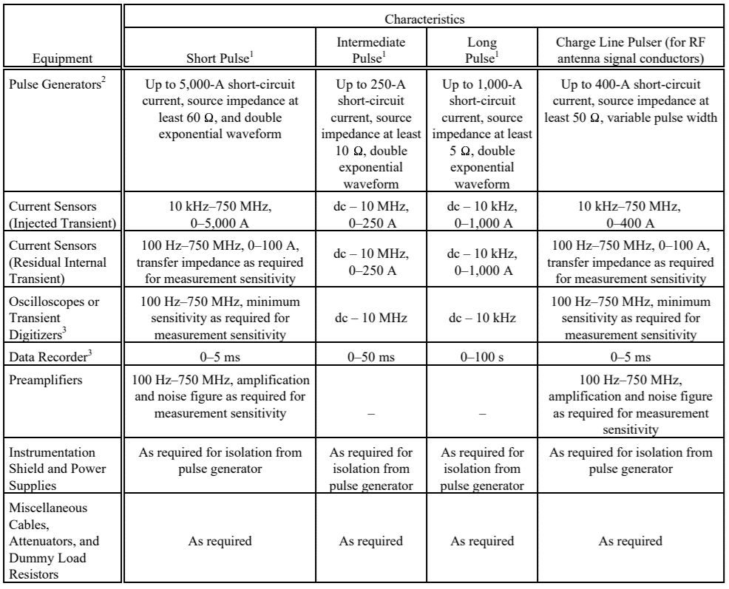The HEMP waveform is generated based on the given requirements. As the current project is based on HEMP short pulse generation, characteristics of the short pulse are derived from the proposed MIL-STD values.

**Table 3.1.1: PCI test equipment requirements**

1. See table 3.1.2 for characteristics of the short, intermediate, and long pulses.
2. Pulse generator short-circuit current requirements are stated in terms of current delivered through a short circuit at the 2generator output terminals. Source impedance is the ratio of the generator peak open-circuit voltage to the peak short circuit current. The method of coupling the pulse generator output to the penetrating conductor is not specified. However, connection of the pulse generator into the circuit under test must not interfere with normal circuit operation.
3. Use of a personal computer with an IEEE-488 general purpose interface bus (GPIB), or equivalent, to control instrumentation and store test data on magnetic disk is strongly recommended.

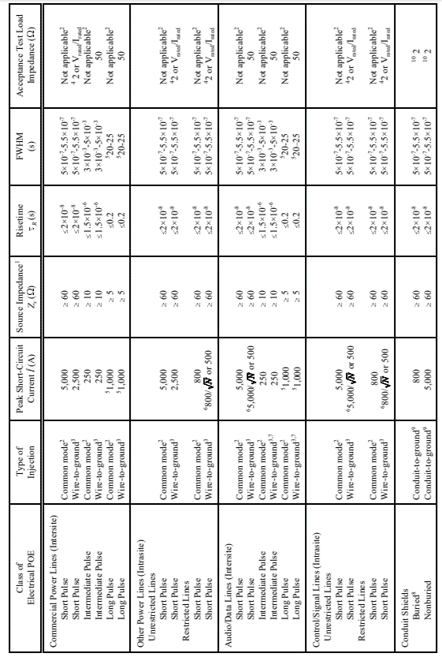

**Table 3.1.2: PCI source parameters, waveforms, and acceptance test loads**

1. Source impedance, Z , is defined as pulsar peak time-domain open-circuit voltage divided by pulsar peak time-domain short-circuit current.
2. For a common mode test, all penetrating conductors in the cable are simultaneously driven with respect to ground, where ground is a point on the facility HEMP shield in the vicinity of the POE. Common mode tests are required for verification, but they are not required for acceptance.
3. For a wire-to-ground test, each penetrating conductor in the cable is driven with respect to ground, where ground is a point on the facility HEMP shield in the vicinity of the POE protective device.
4. Whichever is smaller. V and I are the maximum voltage and current ratings of the POE protective device, respectively.
5. The long pulse peak short-circuits current (1,000 A) and FWHM (20-25 s) are design objectives. Any double exponential waveform with peak 5 short-circuit current $≥$ 200 A, risetime $≤$ 0.2 s, and peak current x FWHM product $≥$ 2 x 10 A-s satisfies the minimum requirement.
6. Whichever is larger. N is the number of penetrating conductors in the cable.
7. Intermediate and long pulse wire-to-ground tests of audio/data lines are required for acceptance, but they are not required for verification.
8. An antenna shield is considered buried when it terminates at a buried antenna and less than 1 m (3.3 ft) of its total length is not covered by earth or concrete fill. A conduit is considered buried when it connects two protected volumes and less than 1 m (3.3 ft) of its total length is not covered.
9. For a conduit-to-ground test, maximum feasible length of the conduit is driven with respect to ground, where ground is a point on the facility 9 HEMP shield in the vicinity of the conduit penetration.
10. Wiring internal to the conduit is terminated at the installed equipment if present. Other internal wiring is bundled together and terminated in common 2ohm resistors at each end. The conduit is electromagnetically closed to the facility HEMP shields at both ends.
11. The dominant response frequency (or frequencies) and threat-level peak short-circuit current are determined from extrapolated coupling measurements.
12. For a shield-to-ground test, maximum feasible length of the antenna line shield is driven with respect to ground, where ground is a point on the facility HEMP shield in the vicinity of the POE protective device.
13. Double exponential waveform (figure 2.1.2).
14. Signal conductor terminated to the shield with 50ohm. The shield conductor is electrically bonded to the facility HEMP shield.
15. Output waveform of the charge line pulsar, with the length of the charge line equal to the quarter-wavelength of the dominant response frequency. If the PCI current requirement exceeds the capability of the charge line pulsar, the short double-exponential pulsar shall be used.
    * + 1. **Analysis of verification test data**

Post-test analysis of PCI verification measured data is required for data corrections for probe and instrumentation response characteristics and conversion of results into norms in engineering units. Additional analysis of measured data shall be performed to assist in developing a definitive statement of facility HEMP hardness. Detailed requirements for post-test analysis of PCI verification test results will be established by the sponsoring agency for the test. They will generally include calculations of threat responses from CW immersion and PCI test data, analysis of verification test adequacy, development of hardness conclusions, and recommendations for corrective actions, if required.

Test data may be classified. DNA-EMP-1 and the classification guide for the specific facility or system should be consulted for guidance.

When approved by the sponsoring agency, cable shield injection may be used for verification testing on shielded intra site control or signal lines in lieu of the common mode PCI requirement. Maximum required current amplitude and the prescribed waveform for cable shield injection shall be as shown in table 3.1.3.

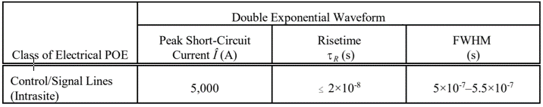

**Table 3.1.3: Required PCI amplitudes and waveforms**

* + - 1. **Detailed requirements**

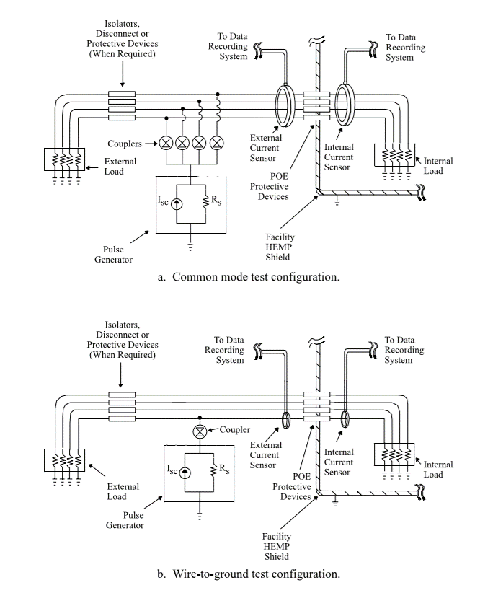Typical PCI test configurations are illustrated in figure 3.1.1, and a typical data recording system is illustrated in figure 3.1.2. The pulse generator output may be directly coupled to the circuit under test, or it may be capacitively or inductively coupled. The external current sensor shall be within 15 cm (6 in) of the external terminal of the POE protective device, and there shall be no branches in the wiring between the sensor location and the external terminal. The internal current sensor shall be within 15 cm (6 in) of the internal terminal of the POE protective device, and there shall be no branches in the wiring between the sensor location and the internal terminal.

**Figure 3.1.1: Typical PCI test configurations**

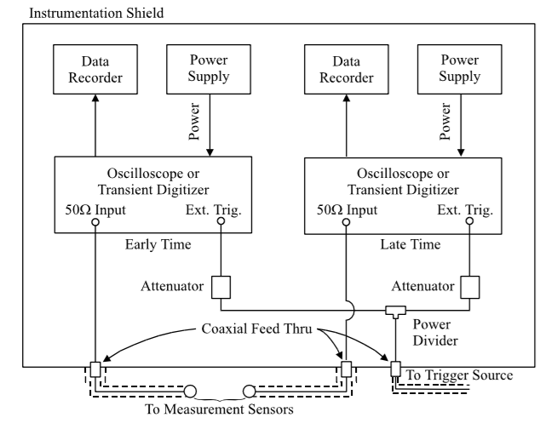

**Figure 3.1.2: Typical PCI data recording system**

* 1. **Simulation Software Used LTSPICE**

 LTSPICE is a SPICE-based analog electronic

circuit simulator computer software, produced

by semiconductor manufacturer Analog Devices

(originally by Linear Technology).It is the most

widely distributed and used SPICE software in  **Figure: 3.2.1**

the industry. Though it is freeware, LTSPICE is not artificially restricted to limit its capabilities (no node limits, no component limits, no sub circuit limits).

* + 1. **Overview**

LTSPICE provides schematic capture to enter an electronic schematic for an electronic circuit, an enhanced SPICE type analog electronic circuit simulator, and a waveform viewer to show the results of the simulation. Circuit simulation analysis based on transient, noise, AC, DC, DC transfer function, DC operating point can be performed and plotted as well as Fourier analysis. Heat dissipation of components can be calculated, and efficiency reports can also be generated. It has enhancements and specialized models to speed the simulation of switched-mode power supplies (SMPS) in DC-to-DC converters.

LTSPICE does not generate printed circuit board (PCB) layouts, but netlists can be exported to PCB layout software. While LTSPICE does support simple logic gate simulation, it is not designed specifically for simulating logic circuits.

It is used by many users in fields including radio frequency electronics, power electronics, audio electronics, digital electronics, and other disciplines.



**Figure 3.2.2: LTSPICE XVII**

* + 1. **Device Models**

LTSPICE ships with thousands of third-party models (capacitors, diodes, inductors, resistors, transistors, ferrite beads, opto-isolators, 555 timer, and more), as well as macro models for Analog Devices and Linear Technology parts (ADCs, analog switches, comparators, DACs, filters, OP Amps, timers, voltage references, voltage supervisors, voltage regulators, 0.01% quad resistor networks, and more). In the device library, Analog Devices part numbers start with "AD", and Linear Technology parts start with "LT".

LTSPICE allows a user to choose from device models that ship with LTSPICE, as well as allows the user to define their own device model, or use 3rd party models from numerous electronic component manufacturers, or use a model from a 3rd party device library. Starting with LTSPICE XVII, control panel settings were added to allow the user to specify search directories for 3rd party device symbols and libraries.

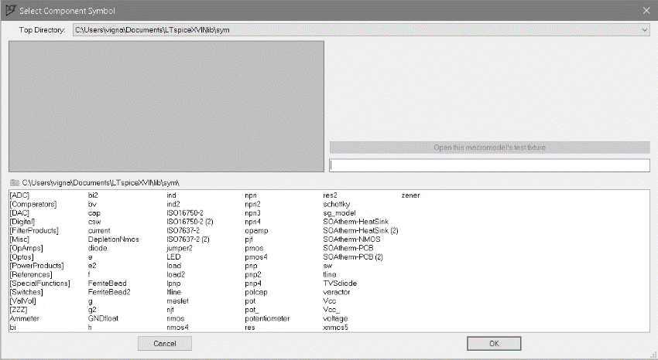

**Figure 3.2.3: LTSPICE model selection window**

* + 1. **LTSPICE directive text**

The text that describes intrinsic SPICE models can be placed directly on an LTSPICE schematic by using the spice directive **.op** button. The advantage of this method is the 3rd party model is self-contained as part of the schematic when you distribute the schematic file. The same .model can also be copied to an ASCII text file on your computer too, but it will not "travel" with a schematic when you copy it to another computer.

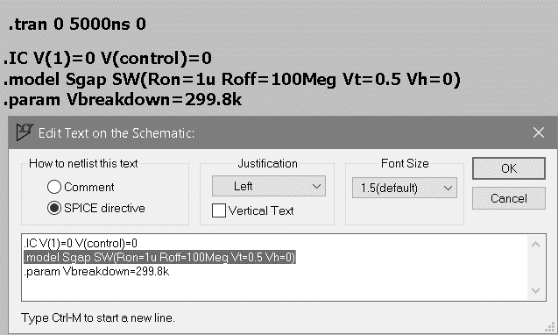

**Figure 3.2.4: LTSPICE-SPICE directive text**

* + 1. **SPICE transient analysis**

A time domain transient analysis is where a parameter such as a voltage or current is plotted against time. If you are looking at an output, you can see the behavior over a specified length of time.

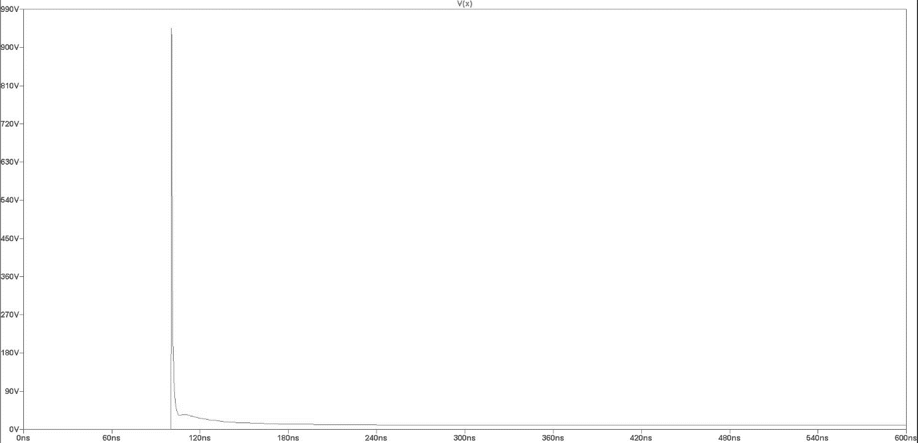

**Figure 3.2.5: LTSPICE-Transient Analysis**

\

1. **Experimental Investigations-Mid Course Correction**

The total project is sub divided into two parts:

1. Generation of HEMP short-pulse using a Marx generator circuit with its characteristics satisfying MIL-STD-188-125 -1&2 using a Marx generator circuit.
2. Suppression of the generated HEMP short pulse using a filter circuit with its characteristics satisfying MIL-STD-188-125 -1&2.

which can be simplified as: 1. Surge Generator

2. Surge Suppressor

* 1. **Surge Generation**

According to the MIL STD 188-125-1&2, the HEMP short pulse is generated using a Marx generator circuit with standard’s rise time (tr) and FWHM (tfwhm).

From table 4.1.1(derived from table 3.1.2), the characteristics for the required short wave for this experiment are given as:

|  |  |  |  |  |  |
| --- | --- | --- | --- | --- | --- |
| **Class of Electrical POE** | **Type of Injection** | **Peak short circuit current (A)** | **Source Impedance (Ω)** | **Rise time tr  (s)** | **FWHM tfwhm  (s)** |
| Short Pulse | Common mode | 5000 | $$≥60$$ | $$≤2×{10}^{-8}$$ | $$5×{10}^{-7}-5.5×{10}^{-7}$$ |
| Short Pulse | Wire to Ground | 2500 | $$≥60$$ | $$≤2×{10}^{-8}$$ | $$5×{10}^{-7}-5.5×{10}^{-7}$$ |

**Table 4.1.1: Characteristics for short pulse**

A Surge generator circuit is to be designed which would satisfy the above characteristics. The surge generator circuit used in this experiment is Marx generator.

* + 1. **Marx Generator design procedure.**

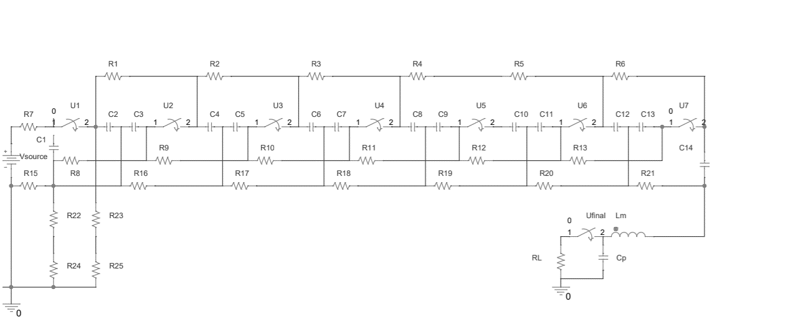Following is the schematic diagram of a Marx generator drawn in the SPICE software with reference to figure 2.2.1

**Figure 4.1.1: 7-stage Marx generator schematic diagram.**

here

Vsource is the source voltage

C1-C14 are charging capacitors

R1-R25 are series resistors.

U1-U7 are spark gaps

Cp is the wave characteristics capacitor

Lm is the wave characteristics inductor

Rl is the load resistor

Ufinal is the wave characteristics circuit spark gap.

For the simple error free simulation, the following circuit is further simplified into single stage Marx generator using equivalent elements.

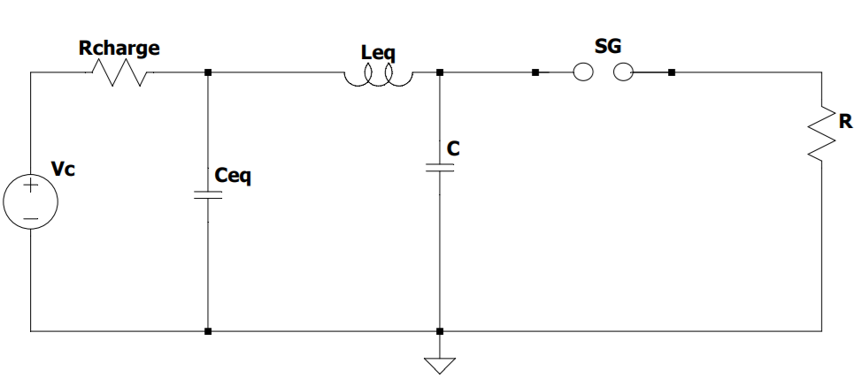

**Figure 4.1.2: Equivalent Single-stage Marx generator circuit.**

here

Vc is the voltage stored in the capacitor Ceq

Ceq is the equivalent capacitance of the capacitors C1-C14

Rcharge is the charging resistor

Leq is the equivalent inductance of the circuit.

C is the wave characteristics capacitor

R is the wave characteristics Resistor

SG is the final Spark gap.

The load of the pulse generator is designed as 10K Ω. According to the MIL STD 188-125, the full width half maximum (FWHM) for a short pulse should be between 500 ns to 550ns. Then the equivalent total capacitor of this Marx generator **Ceq** can be calculated by equation (1):

T0.5=0.693RlCeq  (1)

**Note:** Time constant in the circuit= $R×C$ (from $V_{cap}=6000(1-e^{\frac{-t}{RC}})$). By rule of thumb, the time taken for capacitor to charge/discharge 99% is 5R1Ceq and to charge/discharge 50% is 0.693R1Ceq

As a result, the value of Ceq is 221.3 pF, then the value of each capacitor C (C1-C14 in figure 4.1.1) is C=14Cm=3.1 nF. For rough estimation, the whole inductance of Marx generator Lm is about 0.007H. Equation (2) could be used to calculate the value of peaking capacitor.

$C=\frac{Leq}{R^{2}}$ (2)

**Note:** Therefore, the value of peaking capacitor is 0.99pF. As this is a simulated circuit and involves modeled circuit element, which would be discussed later, the calculated values might be different from the values that are actually used.

As the design of the circuit is completed, design of a spark gap model, which is absent in the LTSPICE’s official circuit elements library is done.

* + 1. **Spark-gap design procedure**

Spark gap design in LTSPICE involves 2 steps: 1. Design of sub-circuit

2. Design of symbol

* + - 1. **Spark gap sub circuit.**

Even though LTSPICE does not contain any switch models for easy simulation of spark gaps, it contains voltage-controlled switches, which will be used for spark gap modelling.

**Model 1.**

Figure 4.1.3 consists of LTSPICE spark gap basic model. This is the first approach to the actual final model.

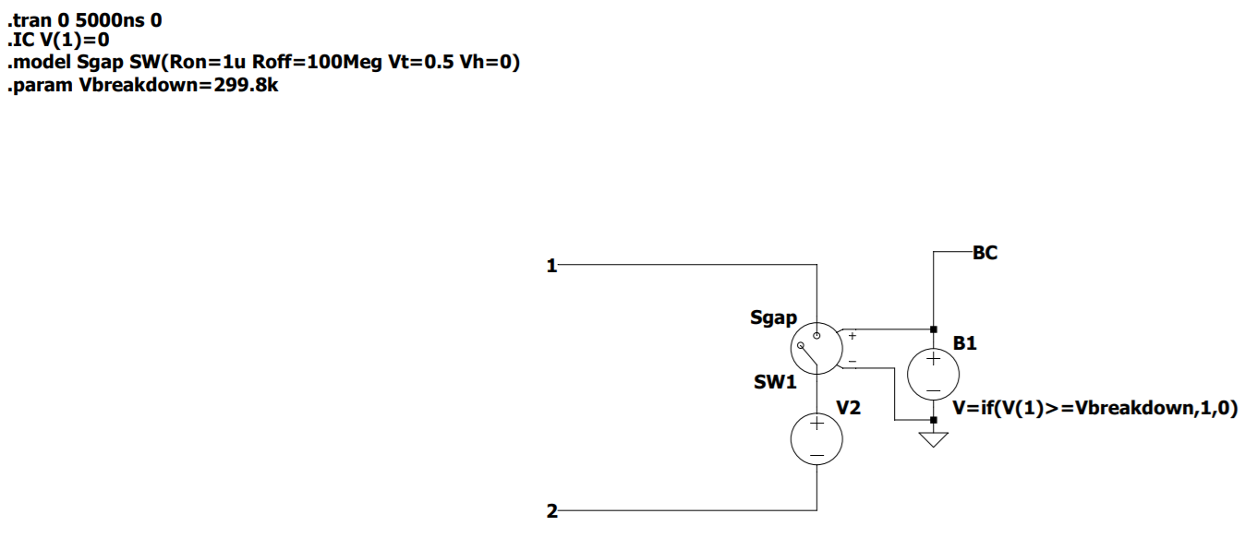 Model lines

**Figure 4.1.3: LTSPICE spark gap model first approach.**

1. .trans 0 5000ns 0 line is for setting the running time values of the transient analysis.
2. .IC V(1)=0 line is initial condition for voltage drop across pin1 that is set to 0V.
3. .model Sgap SW1(Ron=1u Roff=100Meg Vt=0.5 Vh=0) is the model line for voltage-controlled switch SW1. Ron is the resistance at on position. Roff is the resistance at off position Vt is the threshold voltage and Vh is the hysteresis voltage.
4. .param Vbreakdown is the defined breakdown voltage of the spark gap model.
5. In the figure terminals 1 and 2 are connecting pins in the actual final model. The names and number of pins should be same as in the designed symbol.
6. SW1 is the voltage-controlled switch.
7. V2 is a reference voltage source with 0V. It is used to measure current in the path.
8. B1 is the Arbitrary behavioral voltage source. This controls the gap switching placed in the schematic by selecting BV. It is defined by an equation.
9. B1’s voltage equation: V=if(V(1)>=Vbreakdown,1,0) is a simple if else formula. If voltage drop across terminals> breakdown voltage, then BV=1V else it is 0V.

**Disadvantages of model 1.**

* LTSPICE treats this circuit as analog and it fluster if something changes too quickly, in this case the switching takes place too quickly.
* Occurrence of logical error. The switch closes as soon as the capacitors charge to the given voltage but as the current flows through the spark gap, the voltage drops across the capacitor immediately thus making the switch open immediately .We need to keep this switch closed.

**Model 2.**

Figure 4.1.4 consists of LTSPICE spark gap final model. This is the final approach to the actual final model, and this solves the problem of keeping the switch closed.

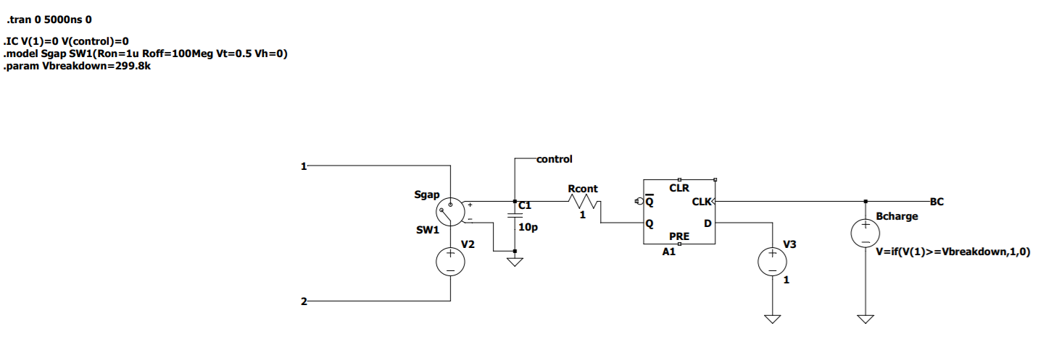

Model lines

**Figure 4.1.4: LTSPICE spark gap final approach.**

1. .trans 0 5000ns 0 line is for setting the running time values of the transient analysis.
2. .IC V(1)=0 V(control)=0 line is initial condition for voltage drop across pin 1 and node control which are set to 0V.
3. .model Sgap SW1(Ron=1u Roff=100Meg Vt=0.5 Vh=0) is the model line for voltage-controlled switch SW1. Ron is the resistance at on position. Roff is the resistance at off position Vt is the threshold voltage and Vh is the hysteresis voltage.
4. .param Vbreakdown is the defined breakdown voltage of the spark gap model.
5. In the figure terminals 1 and 2 are connecting pins in the actual final model. The names and number of pins should be same as in the designed symbol.
6. SW1 is the voltage-controlled switch.
7. V2 is a reference voltage source with 0V. It is used to measure current in the path.
8. A D flip flop is added to the circuit to keep the switch closed.
9. A1 is a D flip flop whose D input is set to a constant 1V from V3 and the clock input is given from arbitrary voltage source Bcharge whose voltage is defined by an equation.
10. Bcharge’s voltage equation: V=if(V(1)>=Vbreakdown,1,0) is a simple if else formula. If voltage drop across terminals> breakdown voltage, then BV=1V else it is 0V.
11. Direct feed of voltage from Q of D flipflop A1 to SW1 does not work as the switching is still high for LTSPICE to work.
12. C1 and Rcont together is a RC control circuit used to generate a 10ps (timeconst=R×C=1Ω×10pF=10ps) delay for the LTSPICE to work.
13. Node’s voltage named as ‘control’ controls the switching action of the spark gap(voltage-controlled switch SW1).

The sub circuit part of the spark gap modeling is completed. A symbol for the Model 2 (figure 4.1.4) is to be designed for actual usage in the Marx generator circuit.

* + - 1. **Spark gap symbol design.**

Design of a spark gap symbol and linking it to the respective sub circuit part is relatively easy task.

* To create a new symbol: **LTSPICE XVII>File>New symbol.**

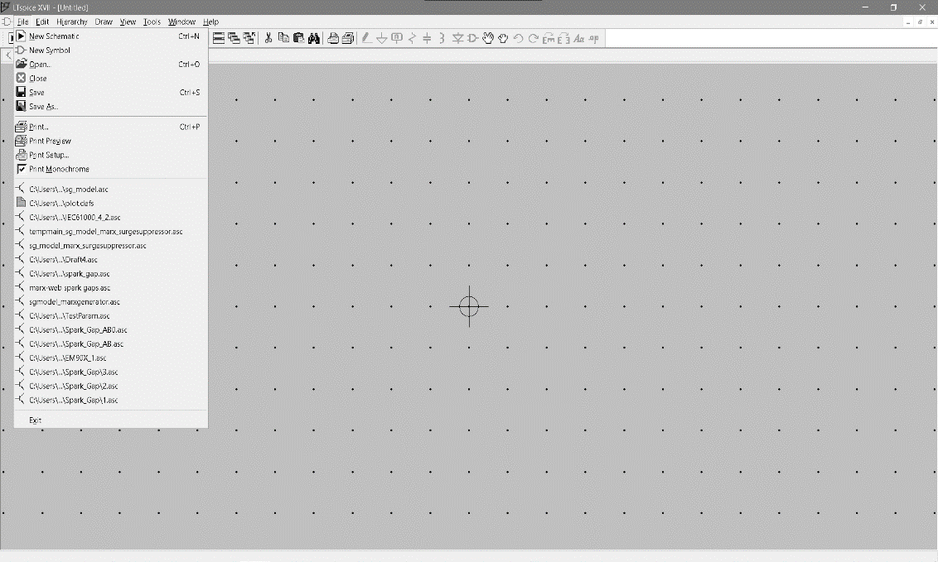

**Figure 4.1.5: Creating New symbol.**

* 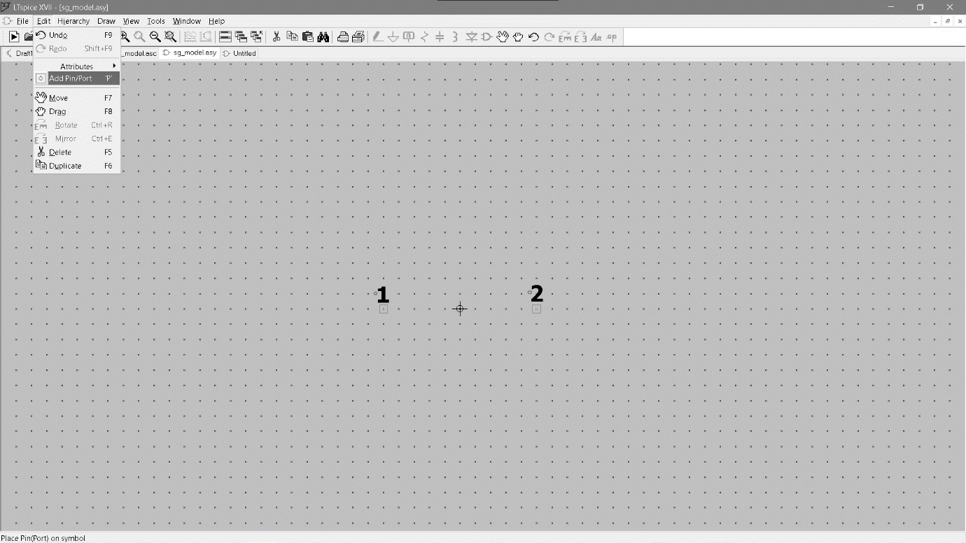Add two pins/ports from: **Edit> Add pin/port**. Name them the same as in the sub circuit(figure 5.1.4). i.e. as **1** and **2**

**Figure 4.1.6: Creating New ports 1 and 2.**

* Now using the shapes in the Draw menu, draw an appropriate spark gap symbol. Add relevant text if needed.

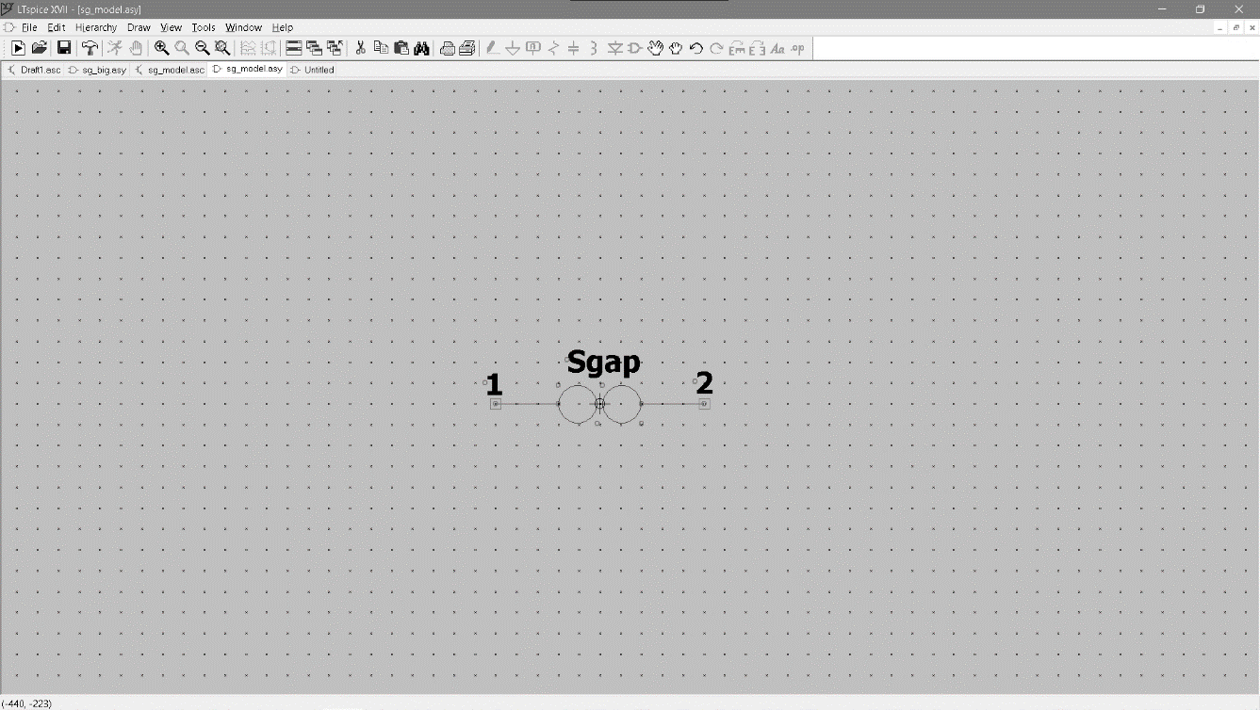

**Figure 4.1.7: Drawing the Spark gap symbol.**

* Save the symbol: File>Save As with the same name as the sub circuit to link the symbol and spark gap sub circuit.
  + 1. **Final Surge generator circuit using modelled spark gap.**

This section describes the design of a circuit using modelled spark gap and Marx generator circuit.

Required wave/pulse characteristics are:

Pulse shape: Double Exponential.

Rise time $t_{r}≤20ns$

FWHM ${500ns≤t}_{fwhm}≤550ns$

Peak short circuit current $≅5000A$

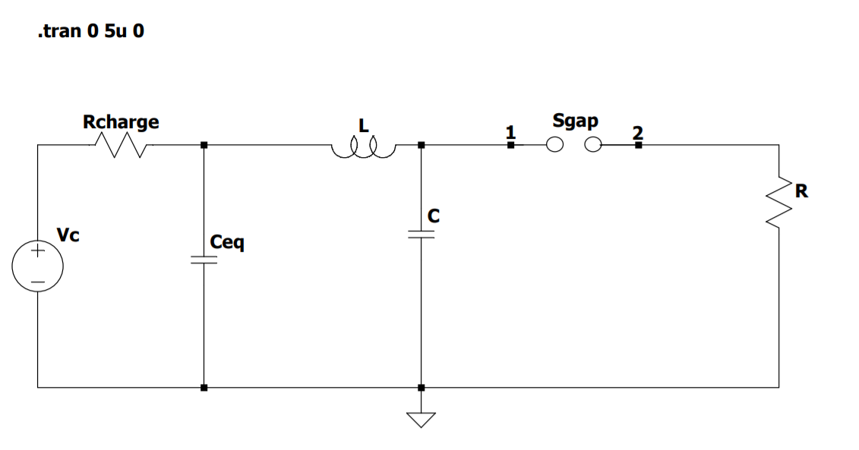

**Figure 4.1.8: Final surge generation Marx circuit with modelled spark gap.**

From the figure 4.1.8, the values of Rcharge, Ceq, L, C and R determine the pulse characteristics.

|  |  |  |  |  |  |  |
| --- | --- | --- | --- | --- | --- | --- |
| **Vc** | **Rcharge** | **Ceq** | **L** | **C** | **Sgap breakdown** | **R** |
| 300KV | 60 Ω | 221.1pF | 0.007H | 0.99pF | 298.8KV | 10K Ω |

**Table 4.1.2: Circuit element values.**

The values from table 4.1.2 gives us the following pulse characteristic values.

|  |  |  |  |
| --- | --- | --- | --- |
| **Pulse shape** | **Peak short circuit current** | **Rise time tr** | **FWHM tfwhm** |
| Double Exponential | 4.8KA | 19.39ns | 538.3ns |

**Table 4.1.3: Pulse characteristics from the circuit element values from table 4.1.2**

**Figure 5.1.9: Double exponential pulse from Marx circuit.**

x-axis: Time in microseconds **(us).**

y-axis: Peak short circuit current**(KA)** through shunt resistor connected in series with **R**.

This is the required MIL STD 188-125-1&2 short pulse that will be given to a HEMP filter circuit.

* 1. **Surge Suppression.**

This approach describes the design process and validation of the design by testing using the MIL-STD-188-125 specified pulses.

The procedure for checking compliance of a HEMP filter with the specification for the E1short pulse is to inject the pulse into the front end of the filter and monitor the residual current flowing through a 2 ohm resistive load connected between the output terminal and earth – see Figure 2.3.1. For higher current filters, the resistive load is replaced by one of value given by V/I where V and I are the voltage and current ratings of the filter. The simplified circuit shown is indicative only to show the key lumped elements. For the E1 pulse, the generator source resistance is specified as 60 ohms as shown in Figure 2.3.1, so the peak applied voltage supplied by the generator needs to be 286.85k. The maximum acceptable residual current through the 2-ohm load is 10A peak, and there are also limitations on residual pulse risetime and energy.

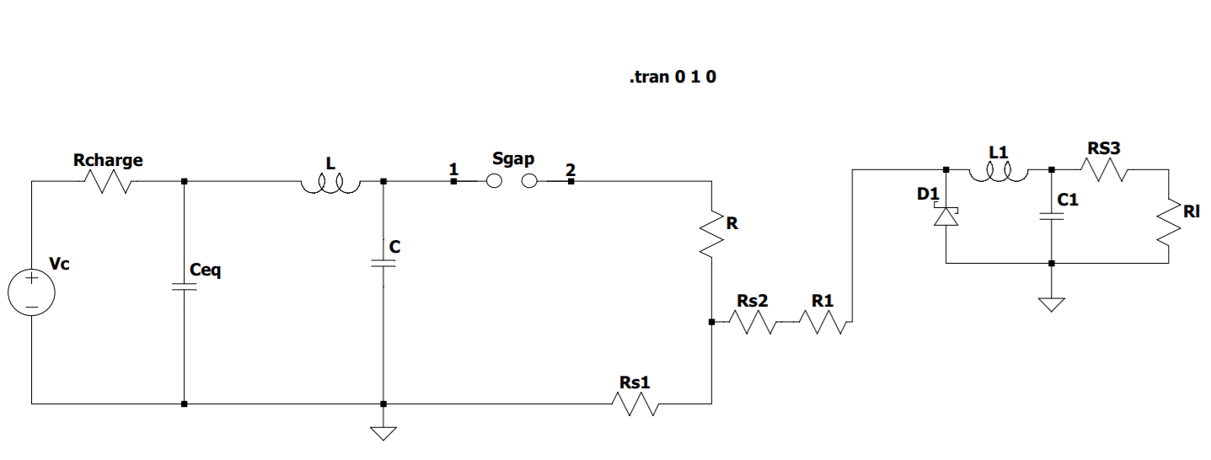**Line to Line filter circuit:**

**HEMP Filter circuit**

**Figure 4.2.1: Surge suppression using HEMP filter circuit.**

1. Circuit elements for surge generator part are same as in the table 5.1.2.
2. Rs1 to Rs3 are shunt resistors used to measure current in the path.
3. D1 is a MOV with breakdown voltage of 880V and average forward current of 10A.
4. R1 =60 Ω and Rl=2 Ω as required by MIL-STD 188-125-1&2.
5. L1 and C1 are filter elements. **(In this case C1=100u and L1=1u)**

|  |  |  |
| --- | --- | --- |
| Current through 60 Ω load | Suppressed current | Current through 2 Ω load |
| 5.001KA | 4.992.5KA | 8.5A peak |

**Table 4.2.1: Currents in the HEMP filter.**

**Figure 4.2.2: Current through resistor Rs2.**

**Figure 4.2.3: Current through MOV D1.**

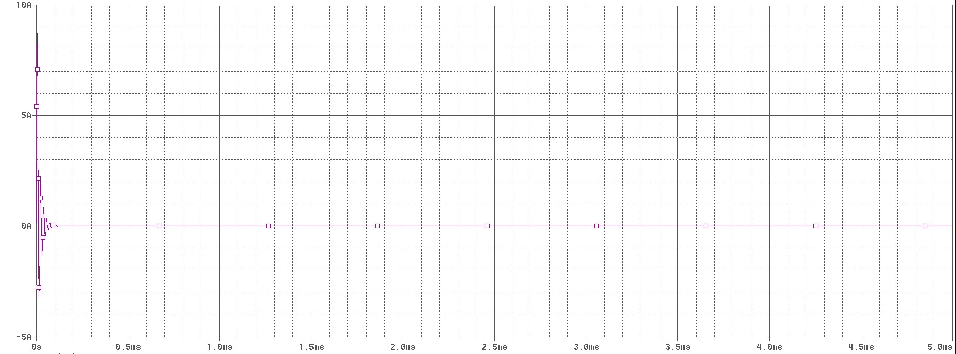

**Figure 4.2.4: Current through resistor Rl.**

**Line to Line ground protection filter circuit:**

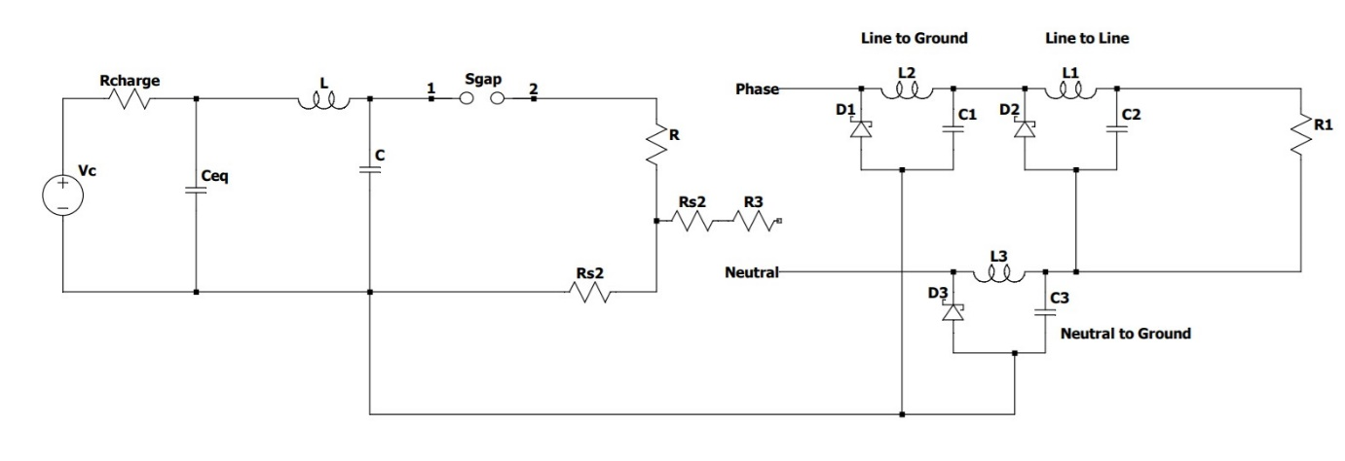

**Figure 4.2.5: Surge suppression using HEMP filter circuit.**

1. Circuit elements for surge generator part are same as in the table 5.1.2.
2. Rs1 to Rs3 are shunt resistors used to measure current in the path.
3. D1,D2 and D3 are MOVs with breakdown voltage of 750V and average forward current of 10A.
4. R1 =60 Ω and Rl=2 Ω as required by MIL-STD 188-125-1&2.
5. L1 and C1 are filter elements. **(In this case C1,C2,C3=100u and L1,L2,L3=1u)**

|  |  |  |
| --- | --- | --- |
| Current through 60 Ω load | Suppressed current | Current through 2 Ω load |
| 2.5118KA | 2.5110.5KA | 7.5A peak |

**Table 4.2.6: Currents in the HEMP filter.**

**Figure 4.2.6: Current through resistor Rs2.**

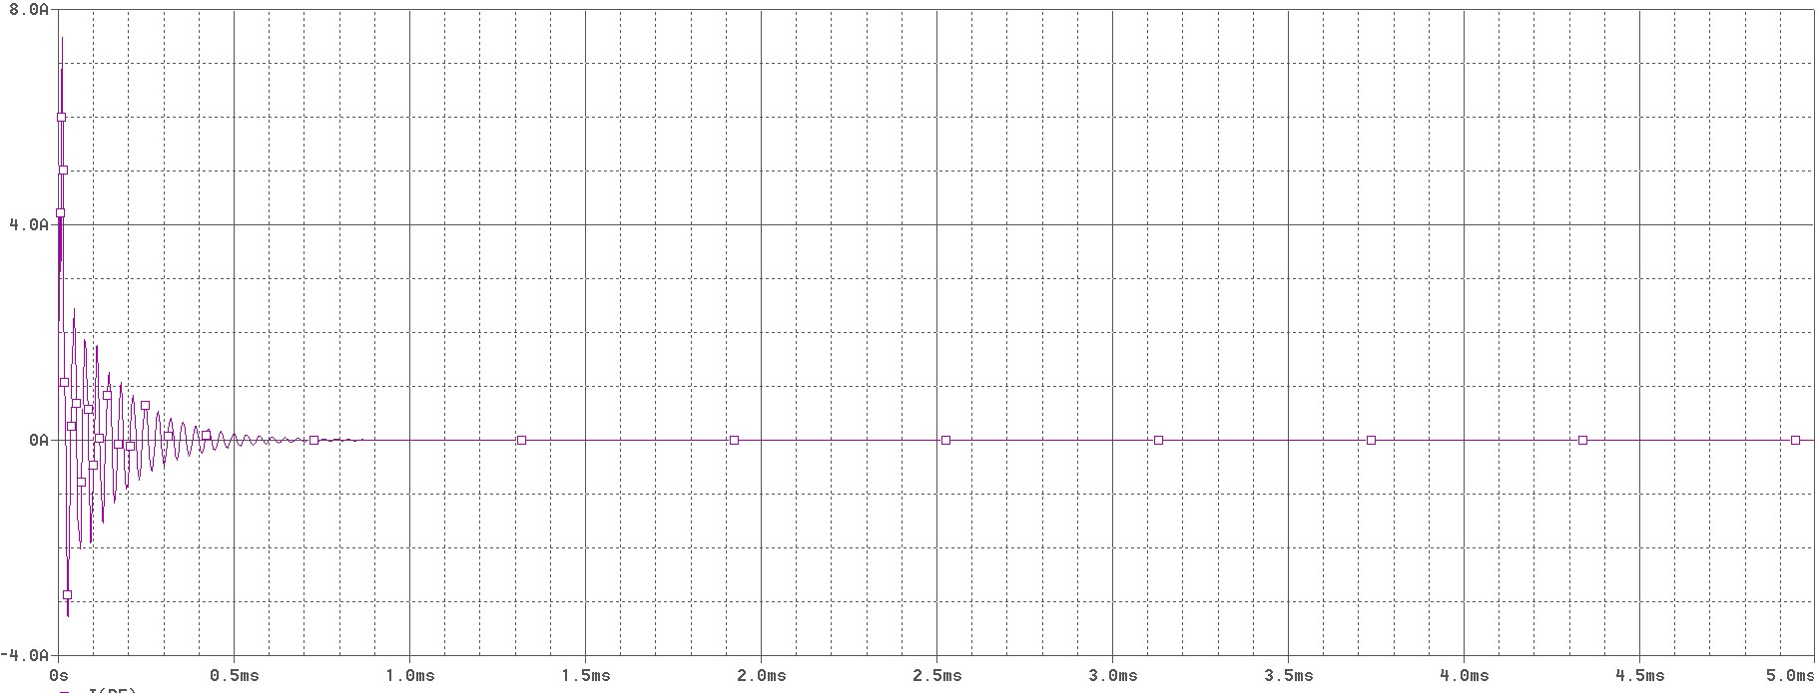

**Figure 4.2.7: Current through resistor Rl.**

1. **Limitations**

The main problem that revolved around the major tasks is the modelling of spark gap. As the spark gap is a physical component with many factors effecting its breakdown voltage, modelling it in a simulation software is very difficult, if not impossible. So in this project, the modelling is done carefully eliminating some of the least important spark gap characteristics and keeping the ones that are only required in this project.

Moreover, there are not many research papers or references related to Marx generator circuit. The wave guiding components are chosen with careful trail and error method, each time checking for the outputs rise time and FWHM.

As the simulation software have libraries which might contain the components we have, simulation of two or more parts of the project in one single simulation software is not feasible. In this project, due to the limitations of ORCAD Capture Lite PSPICE software, modelling of spark gap and simulation is done in LTSPICE. And due to the nonexistence of required MOVs in LTSPICE, filter simulation is done in ORCAD Capture Lite PSPICE.

These are the limitations faced during the completion of tasks. Alternative procedures were used to complete the tasks successfully.

1. **Conclusion**

The simulation of Marx generator circuit and integration of it with a HEMP filter circuit satisfying the standards of MIL-STD-188-125-1 is successfully completed and the desired outputs are obtained.

Further tasks include Filter circuit improvement from satisfying the power electronics to satisfying the communication lines. After the completion of the simulation part, filter construction using circuit components will be done and is to be tested in the company’s labs.

1. **References.**

List of references used in this project:

1. In reference to CE3, Society for Applied Microwave Electronics Engineering and Research, Vizag. Use of lab equipment and study facilities.
2. A parametric SPICE model for the simulation of spark gap switches. <https://doi.org/10.1063/1.5142006> by J. Cameron Pounceya and Jane M. Lehr.
3. Analysis of the triggering behavior of Marx generators using Spice simulations. <https://doi.org/10.1109/PPPS34859.2019.9009676> by B. Lassalle ,F. Bayol and R. Degnon
4. Design of A 500 kV Pulse Generator with the Rise Time of Nanosecond Level. <https://doi.org/10.1109/APEMC.2016.7522874> by Yanpeng Ge, Yanzhao Xie and Zhanyu Li
5. Design of a Marx Generator for HEMP Filter Evaluation Taking Account of Parasitic Effect of Components. <https://doi.org/10.1109/EMCEurope.2016.7739191> by He Jiang , Jiafeng Zhou, Yi Huang, Yuxuan Zeng, Jim Humphries, Qian Xu and others.
6. Gas Discharge Tube Modeling with PSpice. [https://doi.org/10.1109/TEMC.2008.2004808](https://doi.org/10.1109/TEMC.2008.2004808%20) by Julio Guillermo Zola
7. A spark gap model for LTspice and similar circuit simulation software <https://doi.org/10.1109/PPC.2015.7296883> by J. Cameron Pouncey and Jane M. Lehr
8. Energy loss in spark gap switches <http://dx.doi.org/10.1063/1.4873706> by V I Oreshkin and I V Lavrinovich.
9. Online Thévenin Equivalent Determination Considering System Side Changes and Measurement Errors <https://www.researchgate.net/deref/http%3A%2F%2Fdx.doi.org%2F10.1109%2FTPWRS.2014.2365114> by Sobhy Mohamed Abdelkader
10. Field-Circuit Co-Simulation of the Marx Generator. **INSPEC Accession Number:**15416368 by Qian Xu1 , He Jiang2 , Yi Huang3 , Jiafeng Zhou4 , Chaoyun Song and Lei Xing.
11. Dept of Defense Interface standard, HEMP Protection for Ground based C4I Facilities performing Critical Time- Urgent Missions MIL-STD-188-125-1.
12. Using the Requirements of the MIL-STD-188-125-1 Concerning Injection of Current Pulse at Testing Resilience of Electronic Equipment to HEMP by Vladimir Gurevich
13. EE6701 - HIGH VOLTAGE ENGINEERING UNIT III -GENERATION OF HIGH VOLTAGES AND HIGH CURRENTS
14. Simulation of Impulse Voltage Generator and Impulse Testing of Insulator using MATLAB Simulink by Ramleth Sheeba1, Madhavan Jayaraju2 , Thangal Kunju Nediyazhikam Shanavas3.
15. A Three-phase Test Circuit Design for High Voltage Circuit Breaker Based on Modeling by Haider Muhamed Umran
16. Psipce Reference Guide by Cadence Design Systems, Inc
17. Pulsed Current Injection Setup and Procedure to Reproduce Intense Transient Electromagnetic Disturbances by Zhitong Cui and Flavia Grassi
18. HEMP Filter Design To Meet MIL-STD-188-125 PCI Test Requirements ANTONI JAN NALBORCZYK Technical Director MPE Limited Liverpool, United Kingdom.